**IFT 266 Introduction to Network Information Communication Technology (ICT)   
  
Lab 5**

**Implement Basic Switch Connectivity**

**After you complete each step, put an ‘x’ in the completed box or answer the open question**

Create the following network topology on Packet Tracer with the addressing scheme provided

For this lab, you can use the 2960 switch

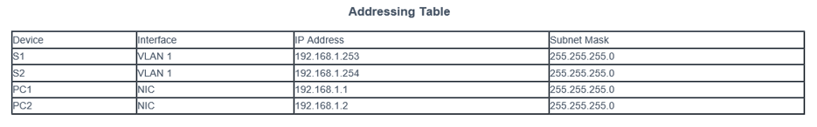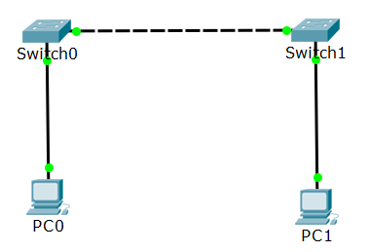

**Part 1: Perform a Basic Configuration on Switch 1 and Switch 2**

1. Configure Switch 1 with a hostname “Castle”

Enter the command here _____________________________________

1. Configure “Castle” with the console and privileged EXEC mode passwords

Enter the commands that will apply the password to the console port here   
  
 _____________________________________

_____________________________________

_____________________________________

Enter the privileged EXEC secret password command here ________________________________

1. Verify the password configurations for Castle  
     
   How can you verify that both passwords were configured correctly?

______________________________________________________________________________

1. Configure an MOTD banner. Use an appropriate banner text to warn unauthorized access

Enter the command here __________________________________________________

1. Save the configuration file to NVRAM.

Enter the command here __________________________________________________

Repeat Steps 1 to 5 for Switch 2 which we will name “Beckett”



**Part 2: Configure the PCs**

Based on the information provided in the addressing table, setup both PCs with their addresses and subnet masks.



**Part 3: Configure the Switch Management Interface**

Configure Castle with an IP address.

Switches can be used as plug-and-play devices. This means that they do not need to be configured for them to work. Switches forward information from one port to another based on MAC addresses.

If this is the case, why would we configure it with an IP address?  
  
 ____________________________________________________________________________

Enter the following commands to configure Castle with an IP address.

Castle# configure terminal

Enter configuration commands, one per line. End with CNTL/Z.

Castle(config)# interface vlan 1

Castle(config-if)# ip address 192.168.1.253 255.255.255.0

Castle (config-if)# no shutdown

%LINEPROTO-5-UPDOWN: Line protocol on Interface Vlan1, changed state to up

Castle (config-if)#

Castle (config-if)# exit

Castle #

Why do you enter the **no shut** command?

_________________________________________________________

Repeat the same steps to configure Beckett (the other switch) with an IP address.



Verify the IP address configuration on Castle and Beckett

Use the show ip interface brief command to display the IP address and status of all the switch ports and interfaces. You can also use the show running-config command.



Save configurations for Castle and Beckett to NVRAM.

Which command is used to save the configuration file in RAM to NVRAM?

_____________________________________________

**Part 4: Verify network connectivity**

Network connectivity can be verified using the ping command.

It is very important that connectivity exists throughout the network.

Corrective action must be taken if there is a failure.

Ping Castle and Beckett from PC1 and PC2

**Attach screenshots of your successful pings!   
(enough screenshots to show me it works)**

**Part 5: Troubleshoot via the “show mac address-table command”**

When you are diagnosing frame forwarding on a switch (frames that are not getting forwarded to the destination node of a switch), MAC address table needs to be inspected to see if the switch has learned the destination Mac address via the show mac address-table command.

